Due in before 4th May.
Complete the worksheet, take a photo and email it to johnkennedy@brillantmont.ch

Name…………………………………………………………………

Draw these complex numbers on an Argand Diagram:
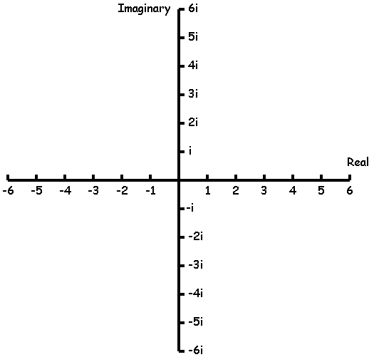

- $z_{1}=3+2i$
- $z_{2}=5+6i$
- $z_{3}=-2+2i$
- $z_{4}=-5+i$
- $z_{5}=-6i$

- $z_{6}=\frac{3}{2}+4i$
- $z_{7}=-\frac{5}{2}+\frac{2}{3}i$
- $z_{8}=-3-\frac{4}{5}i$
- $z_{9}=6(1+i)$
- $z_{10}=\frac{4+2i}{2}$
- For these complex numbers, sketch the solution to each calculation on the Argand Diagrams provided.
$$z_{1}=1+2i$$
$$z_{2}=3-i$$
$z_{3}=-2+2i$
$$z_{4}=i$$

Draw these complex numbers on an Argand Diagram:

- $z_{1}+z_{2}$
- $z_{1}-z_{3}$
- $z_{2}+5z_{4}$
- ${\left(z_{1}\right)}^{2}$
- $z_{2}z_{4}$

- $z_{1}÷z_{2}$
- $z_{2}+z_{3}z_{4}$
- ${{(z}_{4})}^{3}+z_{3}$
- $z_{1}z_{3}÷z_{2}$
- $z_{4}÷z_{1}$

